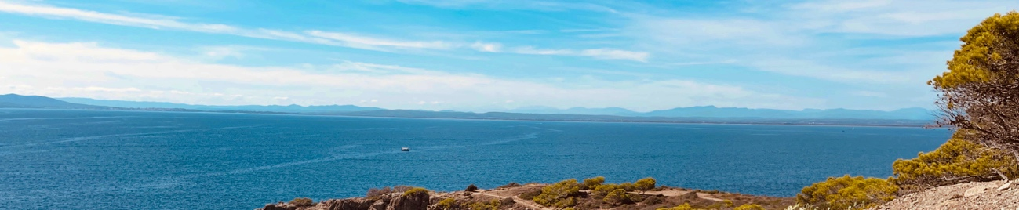
Yoga and Pilates on the Costa Brava
with Marrigje and Elske, from 8 to 14 November 2026
A week full of yoga, Pilates, beautiful walks, delicious food and time to slow down in Roses. Organised by Marrigje, Elske and Olaf.
Join us in November!
November is one of our favourite months on the Costa Brava. The beaches are quiet, the temperatures are pleasant, and it is a perfect time to fully enjoy outdoor life.
Together we have prepared a relaxed week in which yoga and Pilates alternate with beautiful walks, good food, good company and plenty of time to unwind.
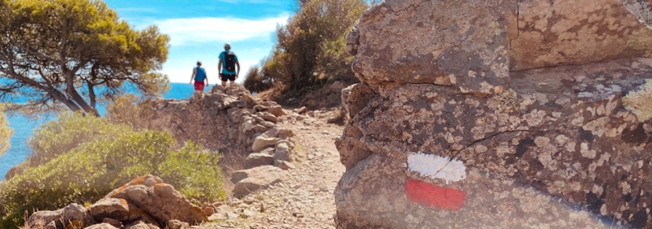
We will move together, discover some of our favourite corners of the coast and, weather permitting, enjoy a quiet afternoon by the pool or on the beach, which is only a two-minute walk from the house.
Whether you come alone, with a friend or with your partner, you will soon feel at home.
Elske, from YogabyElske, has more than 10 years of experience as a yoga teacher in Hoorn (NH), Doha (Qatar), Tuscany (Italy), Koh Phangan (Thailand) and Roses (Spain). Elske teaches creative Vinyasa Flow classes for all levels and is highly appreciated for her relaxing Yin Yoga classes.
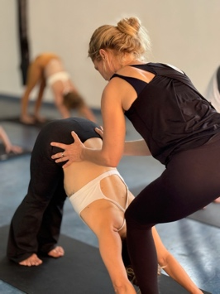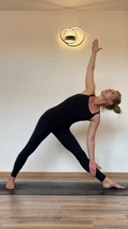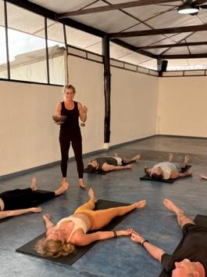
Marrigje is the owner of Marrigje Pilates in Egmond-Binnen. After her ballet training, she specialised in Pilates and yoga. She has been teaching Pilates for 20 years and recently appeared in Yoga by Happinez. During Covid, Marrigje started sharing her classes online and is now followed by nearly 200,000 fans on Instagram.
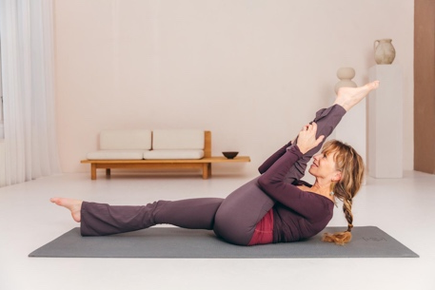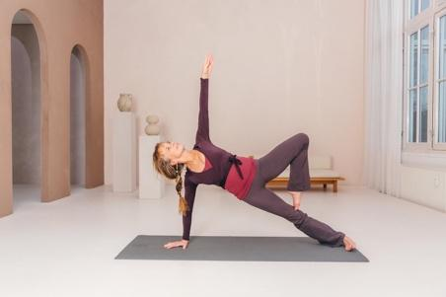
The Costa Brava is a beautiful stretch of coastline north of Barcelona, extending all the way to the French border.
Roses is located in a large bay of the same name, the Gulf of Roses, in the Alt Empordà region. The area is known for its excellent wines, olive oil and gastronomy, and of course for its spectacular nature, hidden coves and beaches.
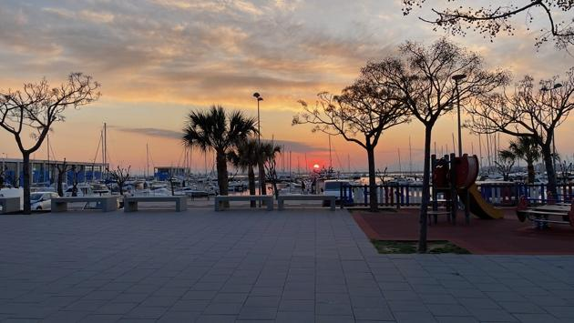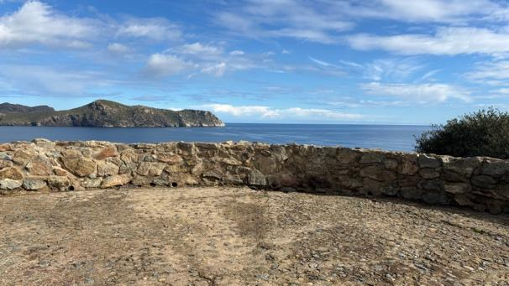
We will walk the beautiful coastal paths and, for those who feel like it, take a swim in the sea at one of the beaches. We will end the day back in Canyelles Petites with a glass of wine and a delicious Mediterranean meal made with local ingredients.
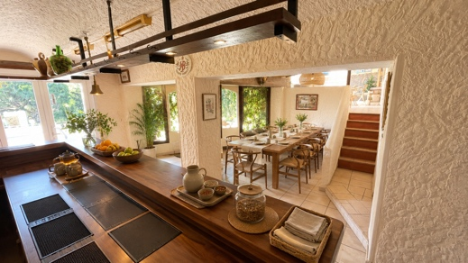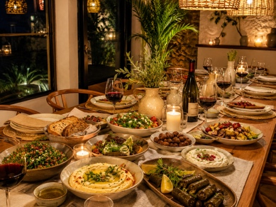
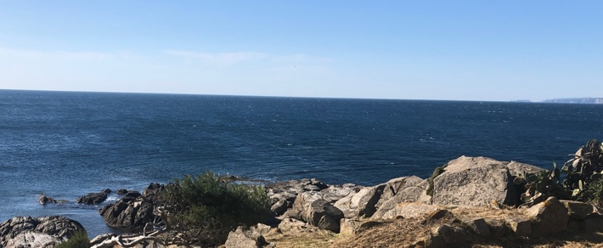
Alt Empordà has its own D.O. and, together with the famous Tramontana wind, is the birthplace of Salvador Dalí. That is why we will also visit his house and/or the museum in Figueres.
In addition to all the physical activity, there will also be plenty of free time to read a book, do nothing or enjoy a relaxing massage.
Be sure to keep reading for an example daily programme and more information about the accommodation and the delicious food we will serve during this retreat.
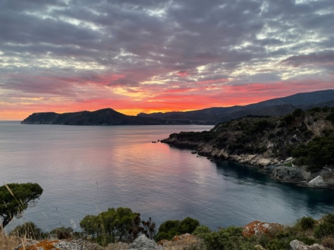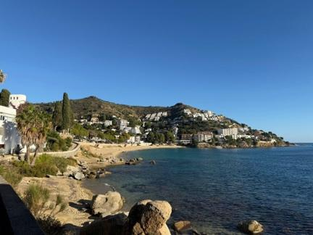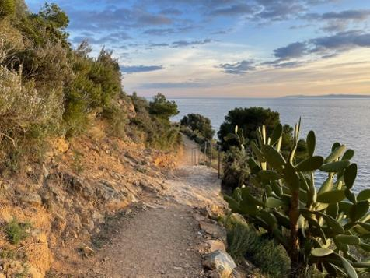
Each day will have a relaxed rhythm.
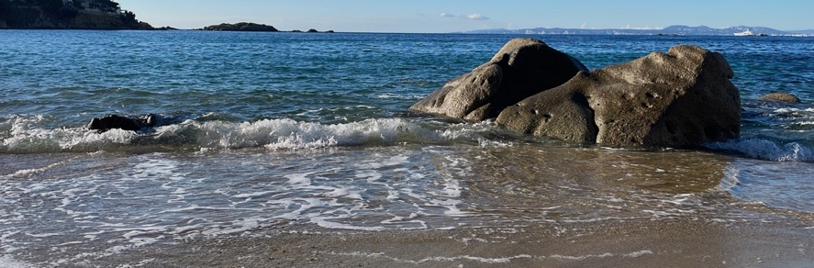
We will start the morning with coffee or tea and a light snack, followed by a yoga or Pilates class. Afterwards, we will sit down together to enjoy a generous brunch.
The afternoons will vary. On some days we will take a beautiful coastal walk, visit a charming village or organise an excursion. If the weather is wonderful, you can also choose to relax by the pool, read a book or take a refreshing swim in the Mediterranean.
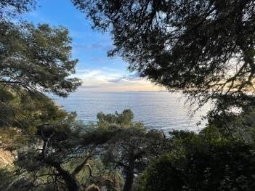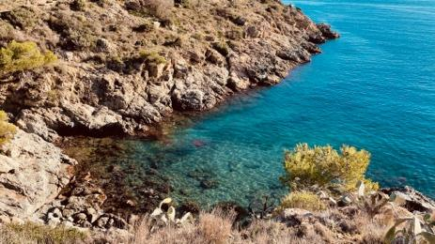
At the end of the afternoon we will come together again for a gentle Yin Yoga or Pilates class. On some evenings we will close the day with Yoga Nidra or a guided meditation before enjoying a delicious dinner together.
This is included:
- 6 nights’ accommodation
- Daily yoga and Pilates classes
- Morning snack, brunch and dinner every day
- Coffee, tea and healthy snacks
- Guided coastal walk(s)
- One special excursion
- Optional wine tasting
- Group transfers to and from Barcelona
- Evening Yoga Nidra and meditation sessions
- Plenty of free time to relax by the pool or on the beach

Not included in the price:
- Travel expenses to Roses (flight, train or car)
- Accommodation before 8 November or after 14 November
- Additional transfer costs from/to the airport if you do not make the included transfer
- Taxi or transport costs in Barcelona, for example to the transfer pick-up point
- Massages
- Alcoholic drinks; there will be an honesty bar with a selection of local wines

Is this retreat for you?
This retreat is for anyone who enjoys yoga, Pilates, nature and good company.
Whether you have been practising yoga or Pilates for years or this is your first introduction to either discipline, all classes will be adapted to the group so that you can take part at your own level and pace.
All you need to bring is comfortable clothing, an open attitude and the desire to enjoy a wonderful week for yourself on the Costa Brava.
Book your spot!
We work with a small group of a maximum of 10 to 12 participants, so there is plenty of room for personal attention.

How can you register for this retreat?
A deposit of 300 euros is required to reserve your place on this retreat. The remaining amount must be paid 45 days before departure.
Send an email to yogahouse@gmail.com for more details.
Payment plans are possible; please contact us.



How do we get to Roses? Practical travel information:
You can reach Roses by plane, train or car. Travel to and from Roses is not included.
We offer a group transfer from Barcelona El Prat airport and a pick-up point in central Barcelona for those who have arrived earlier. You will find more information at the end.
Of course, it is also a great idea to arrive in Barcelona a few days earlier or extend your holiday by a few days after the retreat.
Those who book early can still find return flights from €118. Source: expedia.es, July 2026.
Airports:
Girona Barcelona GRO – 50 km
Barcelona El Prat BCN – 160 km
*Free group transfer BCN–Roses–BCN on 8 and 14 November
Train stations:
High-speed train AVE – Figueres Vilafant – 18 km
Regular train – Figueres – 18 km
*Transfer possible; a taxi costs approximately €35

By car:
Autoroute du Soleil – 1,250 km
*We will be happy to put participants in touch with each other for possible car sharing.
Sunday 8 November: arrival in Roses
To make your journey as relaxed as possible, we organise a shared transfer from Barcelona.
Pick-up times
- Barcelona Airport – around 14:15
- Barcelona city centre – around 15:00

Around 17:00 we will arrive at Costa Brava Yoga House, where we will welcome you with a drink and a delicious snack.
In the evening we will enjoy our first dinner together, followed by a relaxed introduction and a Yoga Nidra session to begin the retreat calmly.
Would you like to enjoy the Costa Brava a little longer? Then you are very welcome to arrive one or two days earlier.
Departure: Saturday 14 November
Please do NOT book flights departing on 14 November before 13:00, as that morning we will need approximately 1.5 hours to travel from our accommodation in Roses to the airport.
On our final morning, we will start the day with one last yoga or Pilates class, followed by a generous breakfast.
After breakfast, we will take you back to Barcelona with the shared transfer (departure time to be confirmed).
Would you like to stay a little longer? Naturally, you can add one or more nights to your stay.

Where will you stay? The accommodation:
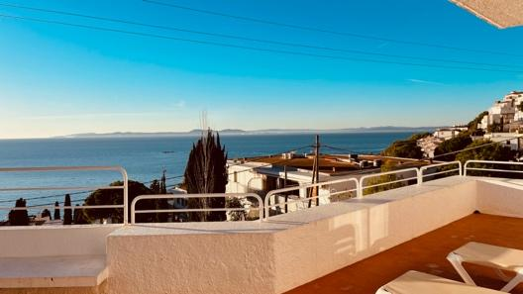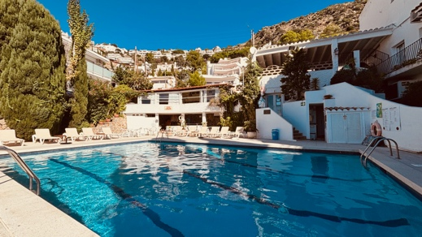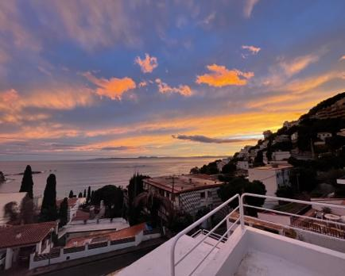

We will stay in the lovely Casa Caliente Apartments in Canyelles Petites, a small and peaceful bay in the municipality of Roses. Casa Caliente is a Dutch family-run business founded in 1964. We will stay in four modern yet simple apartments, built in the late 1980s next to the original holiday complex.

Each apartment has two bedrooms and two bathrooms, a large terrace with sea views, a living room and a kitchen. Although we will spend time together partly in the dining area and yoga room, there will of course be plenty of opportunities to enjoy some peace and quiet in the apartment or on the terrace. There are many cosy corners to discover. The apartments have heating in every room.

The bedrooms will be arranged as a combination of single and double rooms, depending on the participants’ preferences. Each room will be assigned a bathroom.

The bed linen and towels are simple, but of good quality and 100% cotton.

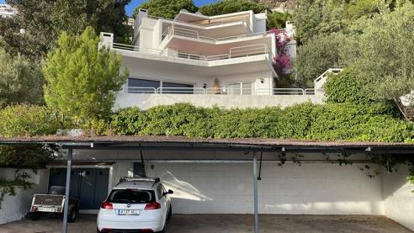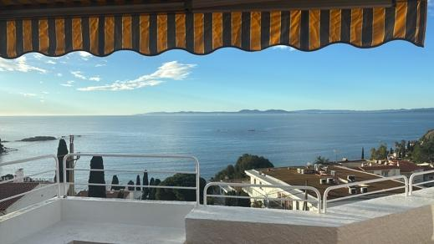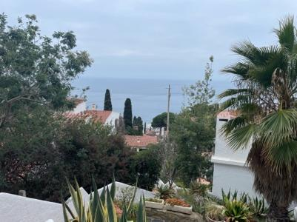

There is good Wi-Fi throughout.

We will have our meals near the yoga room, about 2 minutes from the apartment.

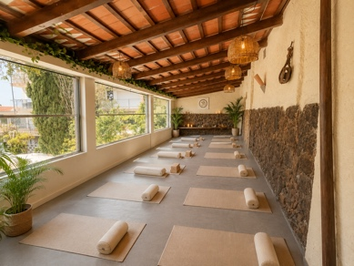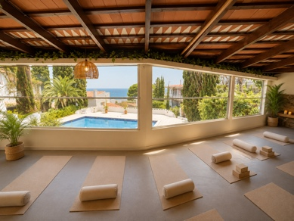
Canyelles Petites is located 5 km from the town of Roses. The bay has a wonderfully peaceful atmosphere, as the season ends in October.
From the bay we will take beautiful coastal walks along the so-called “Camino de Ronda”: a path that follows almost the entire Mediterranean coast to Roses, Cap de Creus and the French border.

About the available rooms:
We offer three different room types for this retreat.

STANDARD BEDROOM with sea view

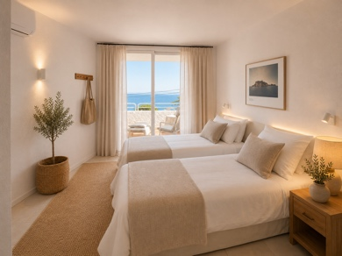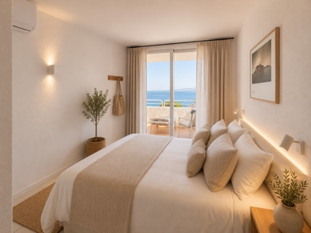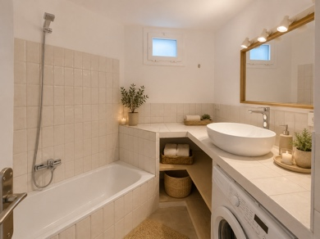

This room can be booked as a single or double room. It has two single beds and access to the terrace.
A beautiful, bright room with sea views and a lovely view of the sunrise.
One of the two bathrooms in the apartment will be assigned to this room.
To book this room as a double room, you should preferably already have a roommate. If you register on your own, we will carefully try to match you with another participant with similar interests. (See the conditions in the pricing section).

STANDARD BEDROOM with garden view

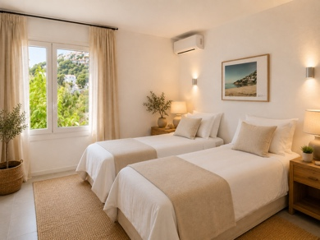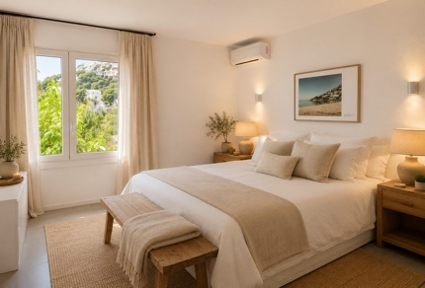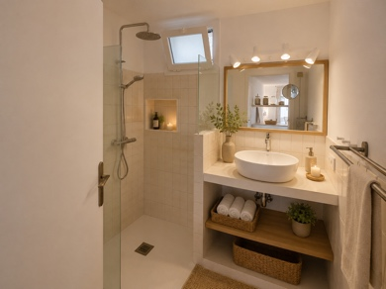

This room can be booked as a single or double room. It has two single beds without direct access to the terrace.
The terrace, with beautiful sea views, can be accessed from the living room.
A beautiful, bright room with views of the garden surrounding the apartment and morning or afternoon sun, depending on the location.
One of the two bathrooms in the apartment will be assigned to this room.
To book this room as a double room, you should preferably already have a roommate. If you register on your own, we will carefully try to match you with another participant with similar interests. (See the conditions in the pricing section).

STANDARD ROOM with garden view (with shared bathroom)
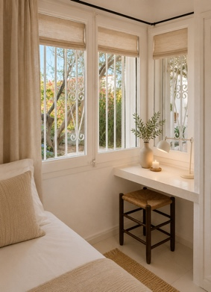

One of the apartments has three bedrooms, with the option to book a room sharing a bathroom.
This room can be booked as a single or double room. It has two single beds without direct access to the terrace.
The terrace, with beautiful sea views, can be accessed from the living room.
A beautiful, bright room with views of the garden surrounding the apartment and morning or afternoon sun, depending on the location.
In these two rooms, you will share the bathroom with another room. The bathroom will be assigned to one of the two rooms in the apartment.

To book this room as a double room, you should preferably already have a roommate. If you register on your own, we will carefully try to match you with another participant with similar interests. (See the conditions in the pricing section).

Do you have questions about the rooms and the different options? Email us at yogahouse@gmail.com and we will be happy to give you more information and explanations.

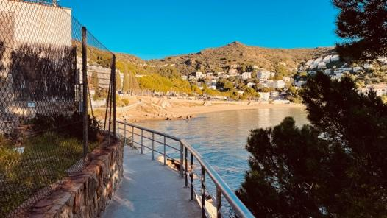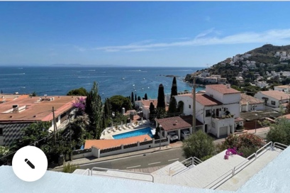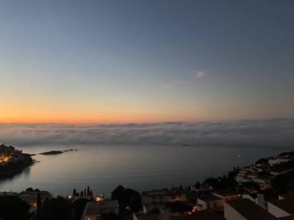

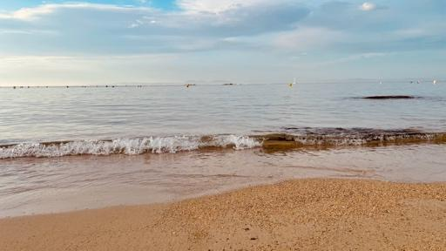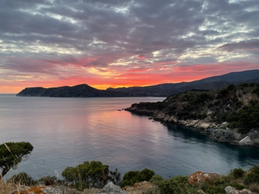

Our prices for the November retreat:
Rooms with sea views (with private bathroom)
4 available
Double room for single use € 1,600.00 [until 31/08 for € 1,360]
Shared double room € 1,400.00 [until 31/08 for € 1,190]

Rooms with garden views (with private bathroom)
Max. 4 available
Double room for single use € 1,500.00 [until 31/08 for € 1,275]
Shared double room* € 1,300.00 [until 31/08 for € 1,105]

Rooms with garden views (with shared bathroom)
Max. 2 available
Double room for single use € 1,400.00 [until 31/08 for € 1,190]
Shared double room* € 1,200.00 [until 31/08 for € 1,020]

*If you already have a roommate in mind, please mention this when booking, together with your bed arrangement preference.
**If you register on your own, we will carefully try to match you with another participant with similar interests. If we are unable to find you a roommate, you will be responsible for paying the single-room supplement. By registering on your own for a double room, you agree to these conditions.

Special offer:
Early bird (until 31/08 inclusive) 15% discount on the listed prices

Example daily programme

Yoga or Pilates
Breakfast brunch
Free time
Nature walk or activity
Relaxation
Yin Yoga
Dinner
Optional Yoga Nidra

What is the weather like in November?

In our experience, November can be a wonderful month. Naturally, the weather in November can be changeable, but on a sunny day, in a pleasant sheltered spot out of the wind, you can comfortably read a book in a T-shirt.

To give you a clear idea, below you will find the average temperatures throughout the year.

Temperature 17 °C – 5 rainy days – 10 hours of daylight

We recommend packing smartly, so you can dress in layers and easily adapt to the conditions.
And yes, bring a waterproof layer too ;-)

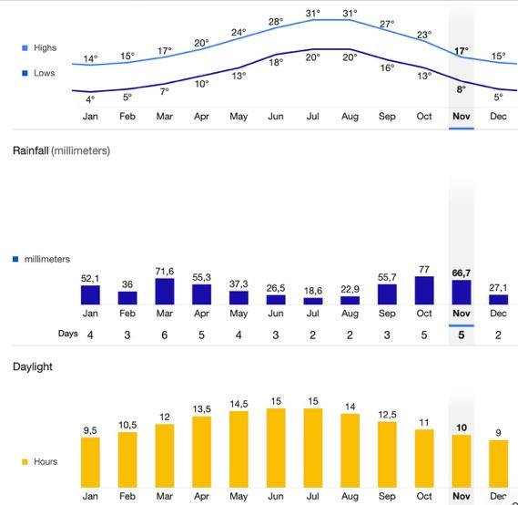

What should I bring? What should I pack?

Broken-in walking shoes and/or trainers
Waterproof jacket
Yoga clothes
Layers, from T-shirts to sweaters
Shorts and long trousers
Swimwear

Cancellation conditions:
For all retreats, a non-refundable and non-transferable deposit of €300 applies and is required to reserve your place on this trip. Remaining payments are also non-refundable and non-transferable.
Costa Brava Yoga House may only make an exception to these conditions if the guest’s country of origin or destination does not allow the guest to travel.

We apply the following cancellation periods and conditions:

- Up to 60 days before the start of the retreat:
100% refund of the selected package.
€300 will be deducted as an administrative fee.
- Up to 45 days before the start of the retreat:
60% refund of the selected package*
- Up to 30 days before the start of the retreat:
30% refund of the selected package*
- Less than 30 days before the start of the retreat:
0% refund of the selected package*

*In all cases, we will try to fill the cancelled place with a new booking, although naturally we cannot guarantee this.
That is why it is important to take out cancellation insurance.
In that case, we will keep the non-refunded amount in our system as credit for a future retreat date for the guest.

If Costa Brava Yoga House has to postpone or cancel the trip, all participants will receive a refund of all amounts paid, minus €200.

We recommend that our participants take out travel and/or cancellation insurance with the provider of their choice. We recommend doing this on the date of booking.

Recommended travel insurance:
Taking out travel insurance is recommended for this trip.
Most policies provide cover for possible delays or trip cancellations caused by airline problems, family emergencies, illness, injuries, etc.
Costa Brava Yoga House is not authorised to sell travel insurance. You are free to choose your own insurer.
We strongly recommend contacting a travel insurance agent to discuss your specific coverage needs and clarify any questions about travel insurance coverage.

Personal data protection:

In accordance with current personal data protection regulations, we inform you that the personal data you provide will be incorporated into the Costa Brava Yoga House file for the purpose of providing the agreed services and informing you about our services. The processing is justified by the contractual relationship.
The data collected about you will not be disclosed to third parties outside our organisation, except in cases where required by law. All personal data collected will be kept in accordance with the guidelines of current legislation. With regard to any of the above points, you may exercise your rights of access, rectification, restriction, erasure and objection, as well as request additional information, by writing to: Costa Brava Yoga House, address: Avinguda Santa Barbara 35, 17480 Roses, or by email to: yogahouse@gmail.com. (Regulation (EU) 2016/679 of the European Parliament and of the Council of 27 April 2016, and Organic Law 3/2018 of 5 December on personal data protection and the guarantee of digital rights).

